Personal Web Portfolio
  - A technical documentation for the design and development process of my personal portfolio website.

Developer
Juan José Castro Zúñiga | Full-Stack DevOps Engineer
Date
May 18, 2026
Main technologies & Frameworks
Azure App Service · Node.js · React · Docker · GitHub Actions
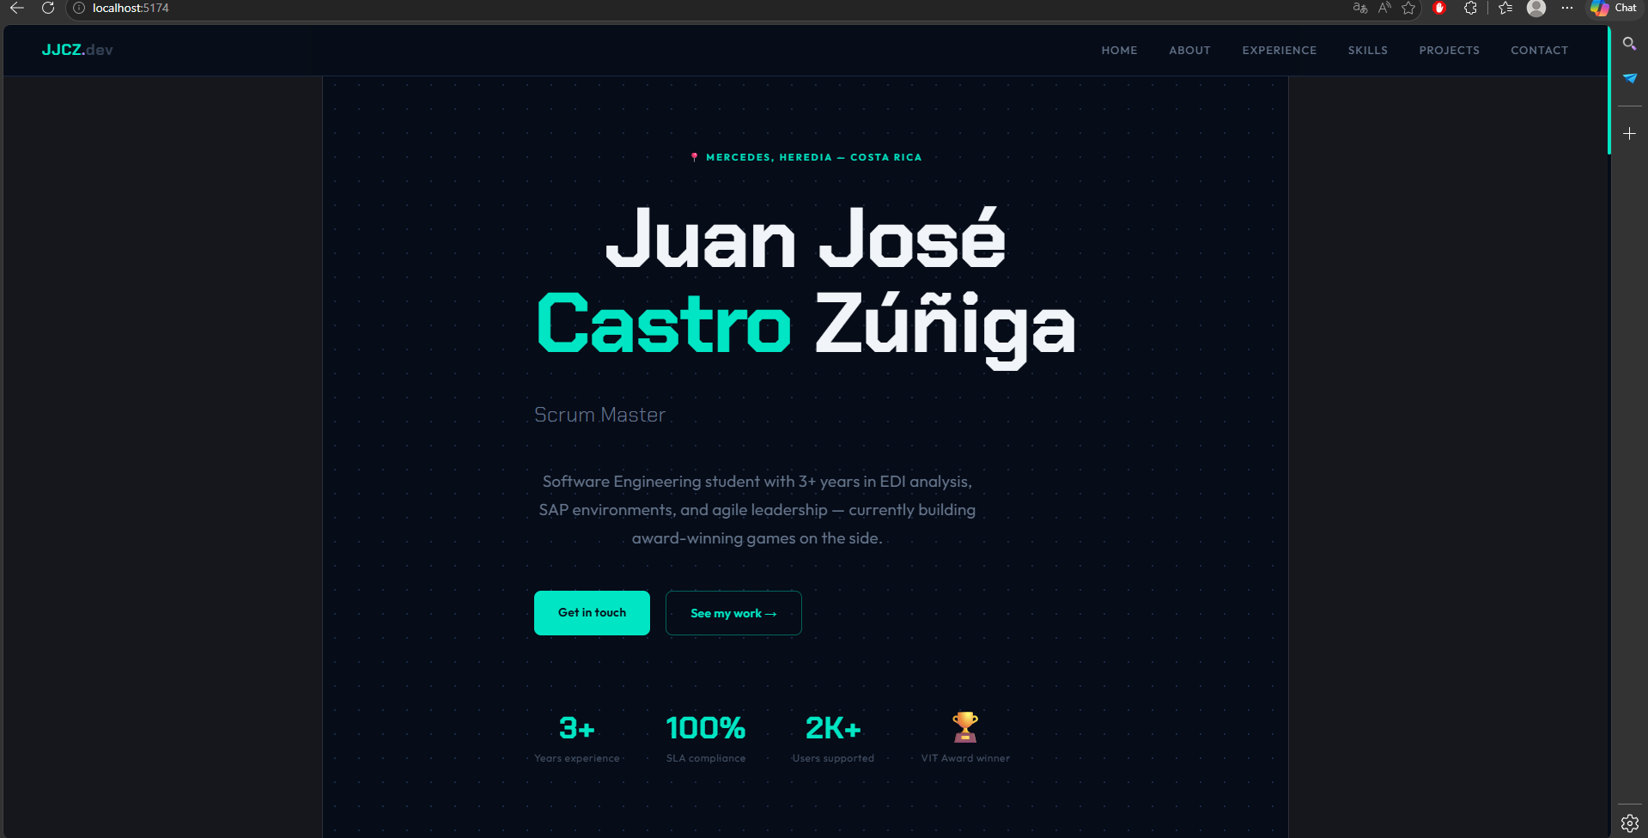
Web development 3
Overview 3
UI 3

Web development

Overview
Created a project using React framework, first hosting locally the website via VITE service and using GitHub as repository.

UI
For the UI, I selected the following color palette:

#0a0a0a  Background | #141414  Cards | #252525  Borders | #cc3333  Primary accent
#f0ece6  Primary text | #b8a082  Logo | #8a8a8a  Secondary text

The website is distributed within a “One Page Design” and the NavBar is a “Sticky” one as it is always visible.

